**LINUX ASSIGNMENT**

1. **How do you use the "cp" command to copy a file named "file.txt" from the current directory to a directory named "backup"?**

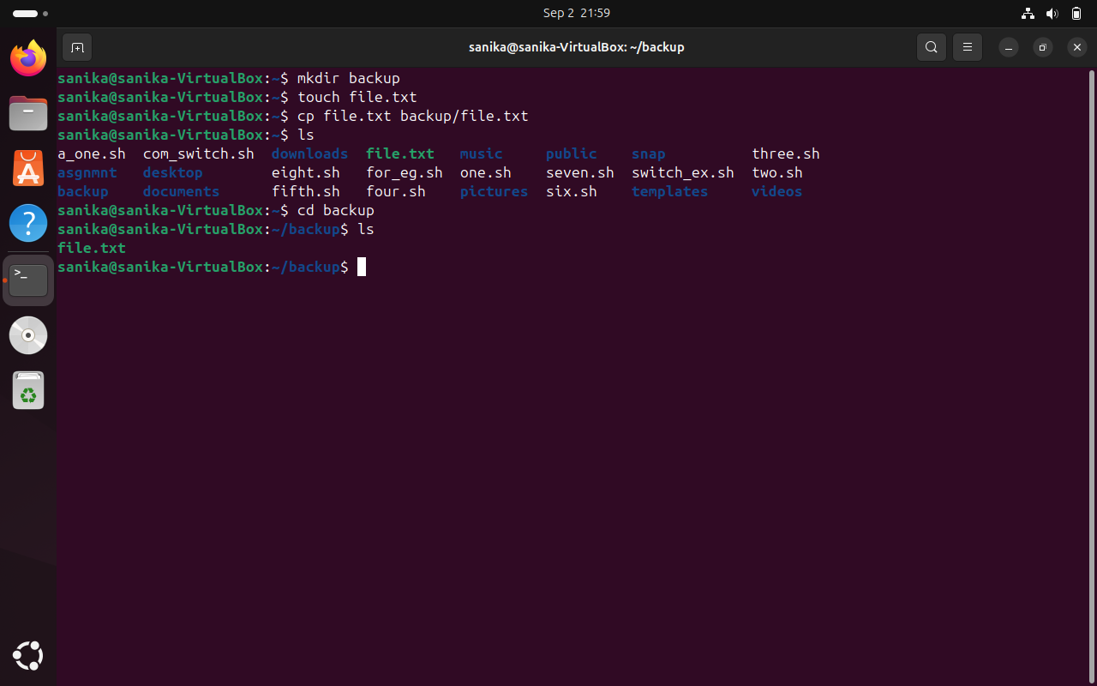

1. **What is the difference between the "rm" and "rm -r" commands in Linux?**

|  |  |  |
| --- | --- | --- |
| **COMMAND** | **RM** | **RM -R** |
| **Description** | Removes files. | Removes directories and their contents recursively. |
| **Usage** | Used to delete individual files. | Used to delete directories and all their contents (files and subdirectories). |
| **Syntax** | rm filename | rm -r directoryname |

1. **How do you use the "mv" command to rename a file named "oldname.txt" to "newname.txt"?**

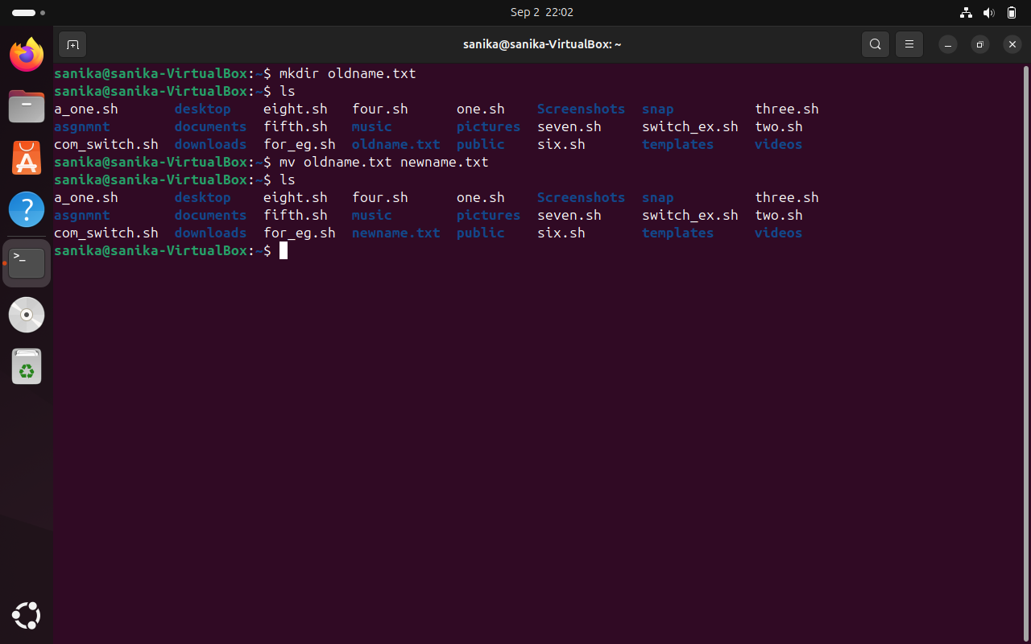

1. **What does the "pwd" command do in Linux?**

The pwd command in Linux stands for “print working directory.” When you run this command, it displays the full path of the current directory you are working in.

1. It can be used to navigate and to know the current directory where the user is working.
2. To know the relative path.
3. **How do you create a new empty file named "newfile.txt" in the current directory using the command line?**

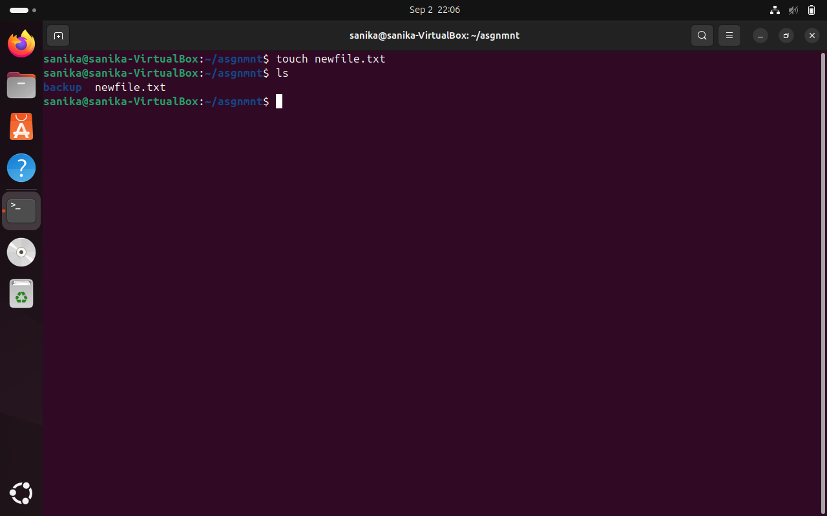

1. **How do you rename a file named "oldname.txt" to "newname.txt" using the command line?**



1. **How do you remove a file named "file.txt" from the current directory using the command line?**

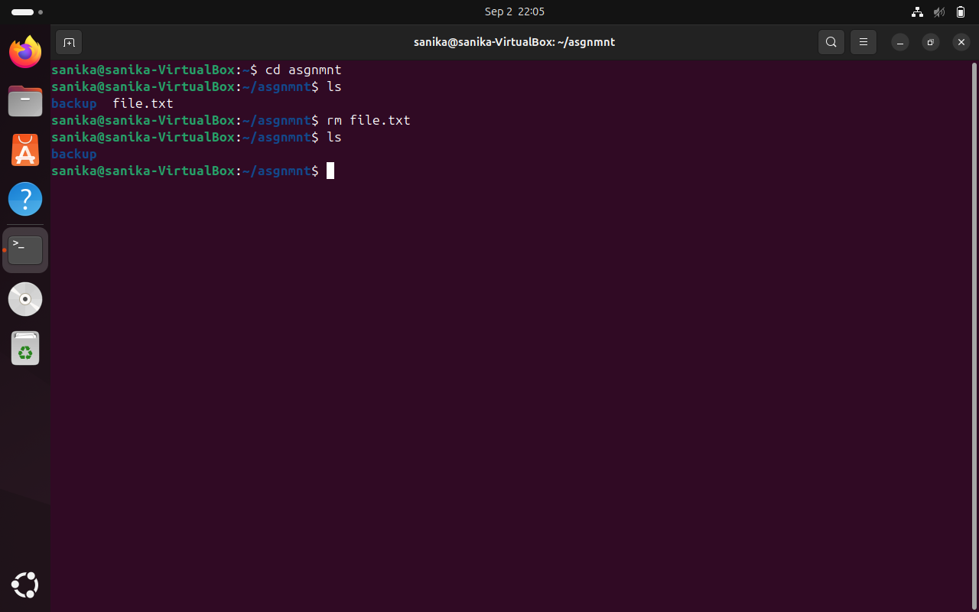

1. **Use a command to show the current working directory**

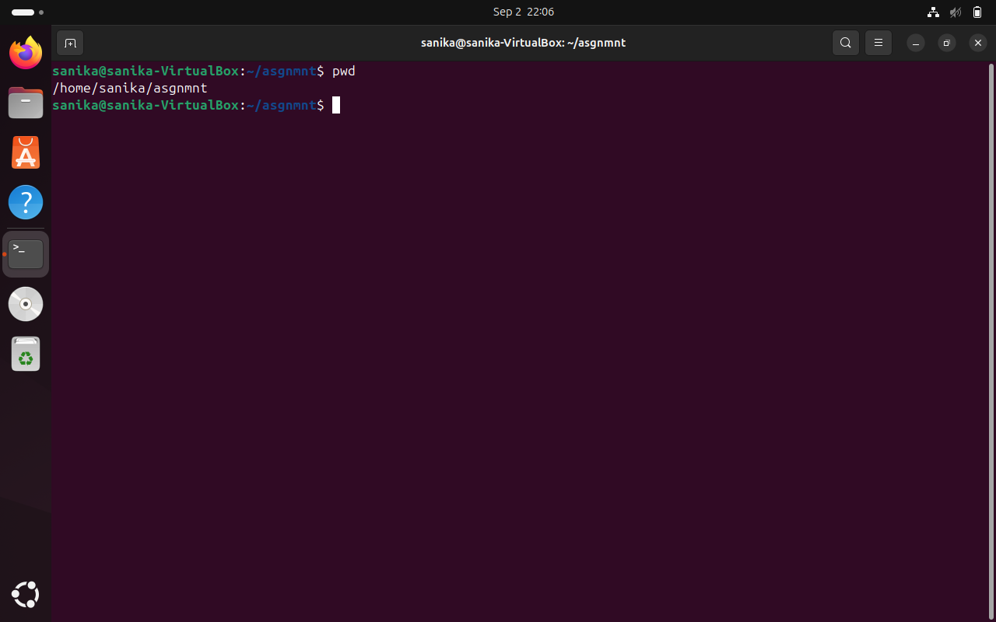

1. **List the directory contents in the short and long format**

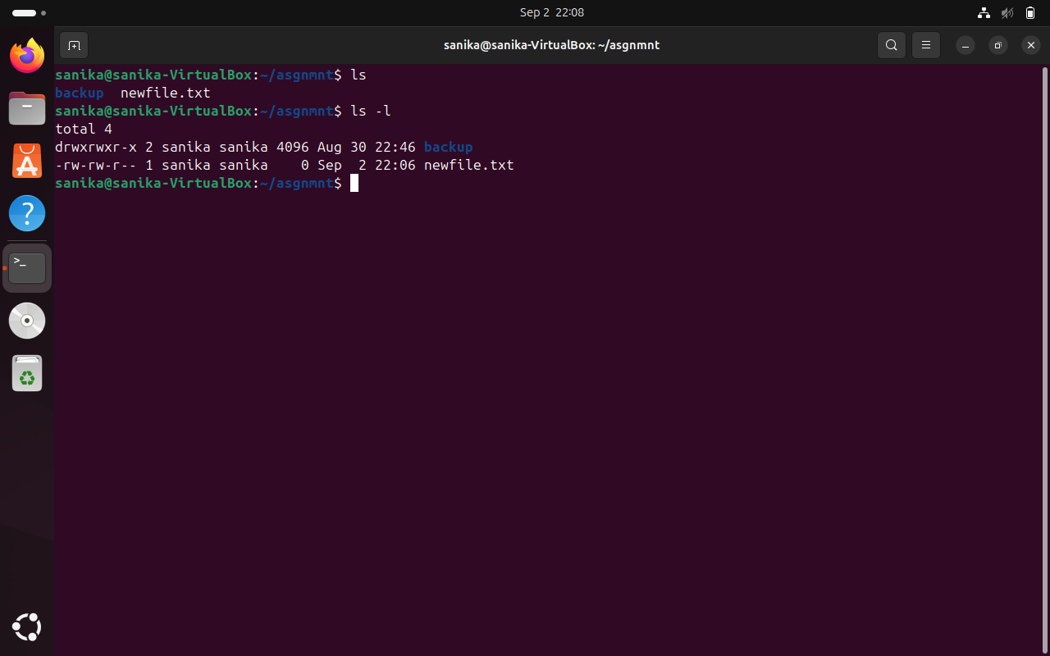

1. **Explore attributes given in long format e.g., file type, file permissions, file size, file owner etc.**

When you use the ls -l command in Linux, it displays detailed information about files and directories in a long format.

Here’s a breakdown of the attributes shown:

**File Type** The first character indicates the type of file

(e.g., - for regular file, d for directory).

**File Permissions** The next nine characters represent the file permissions

(e.g., rw-r--r--).

**Link Count** The number of hard links to the file.

**Owner**  The username of the file owner.

**Group** The group name associated with the file.

**File Size** The size of the file in bytes.

**Modification date** The date and time when the file was last modified.

**File Name** The name of the file or directory.

1. **List all files along with hidden files in the current working directory.**

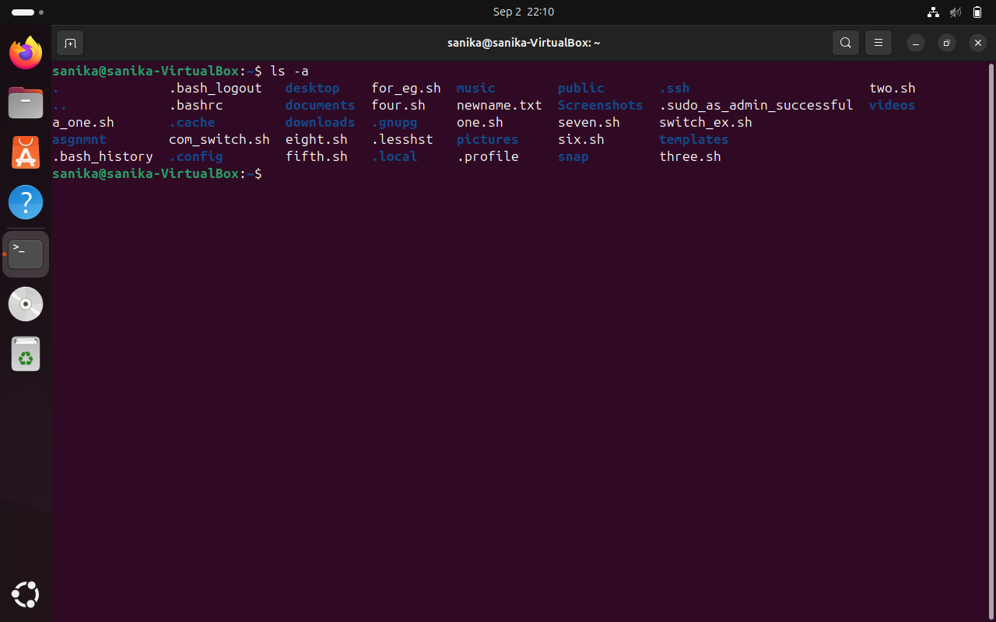

1. **List only hidden files in the directory**

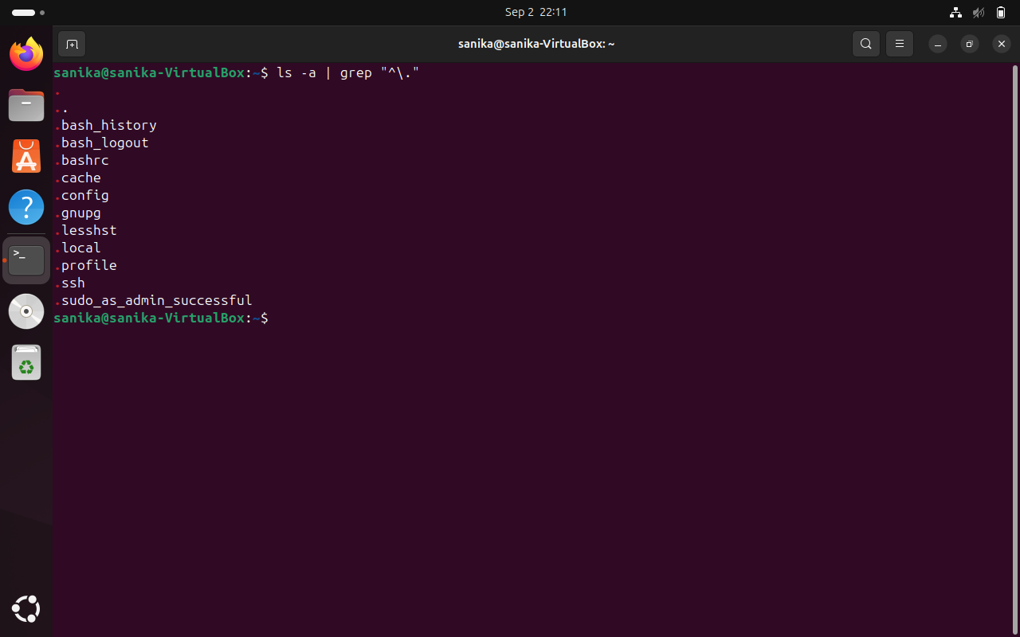

1. **Make a directory and name it as cdac-dir ​and change the current working directory to the new directory. (Hint: use mkdir, cd​ commands). 3. Create following nested directories inside the current directory by invoking a single command for only one time.**

**Note: here root_dir is the current directory.**

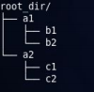 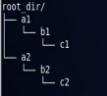

**Directory structure 1 Directory structure 2**

**(Hint: explore the man page of mkdir​).**

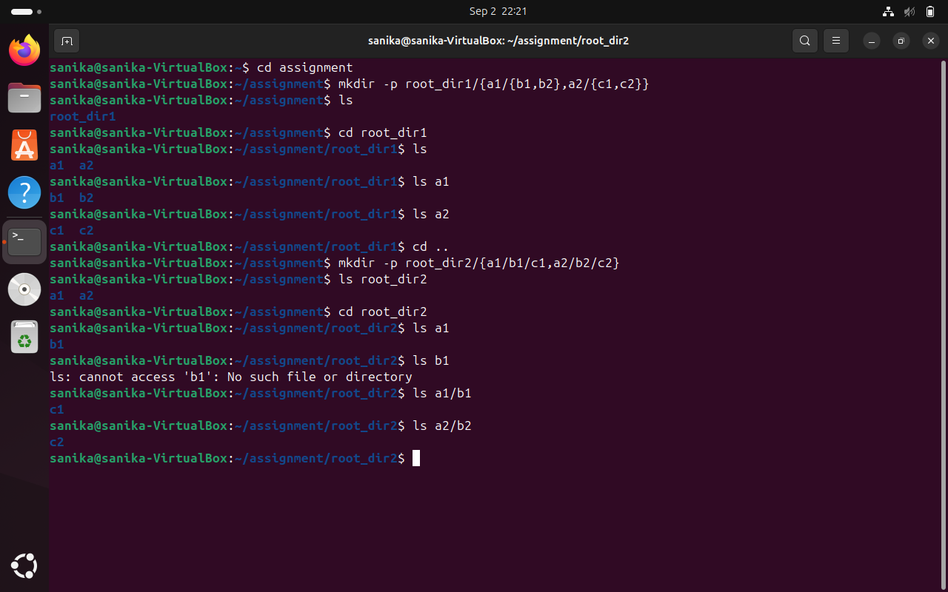

1. **List the directories(folders), then remove the cdac-dir ​directory and list the folders again to show that it is no longer present. (Hint: use rm, ls ​command**

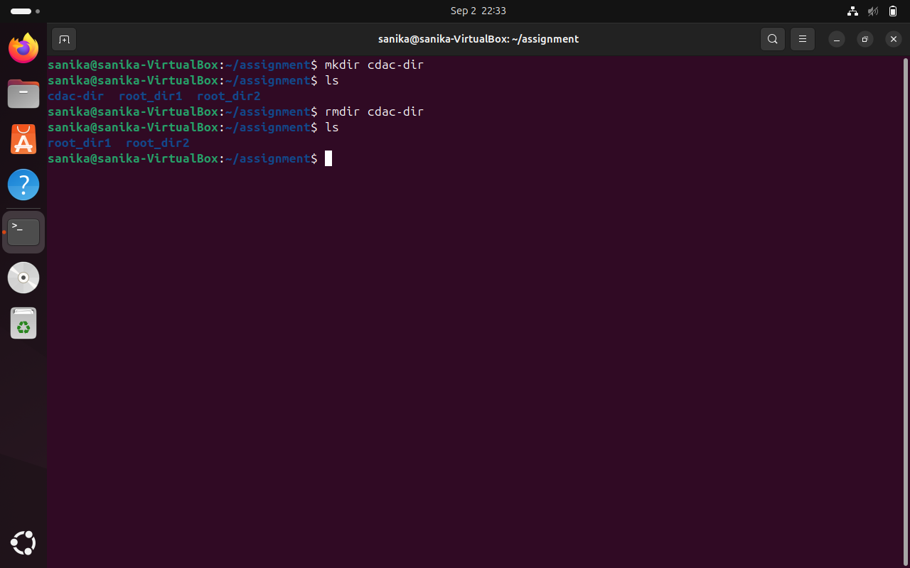

1. **Question-2.**
2. **Display the man-page​ for ls​, but redirect the output into temp.txt​, then use the cat,​ less​, and more​ commands to display the new file.**

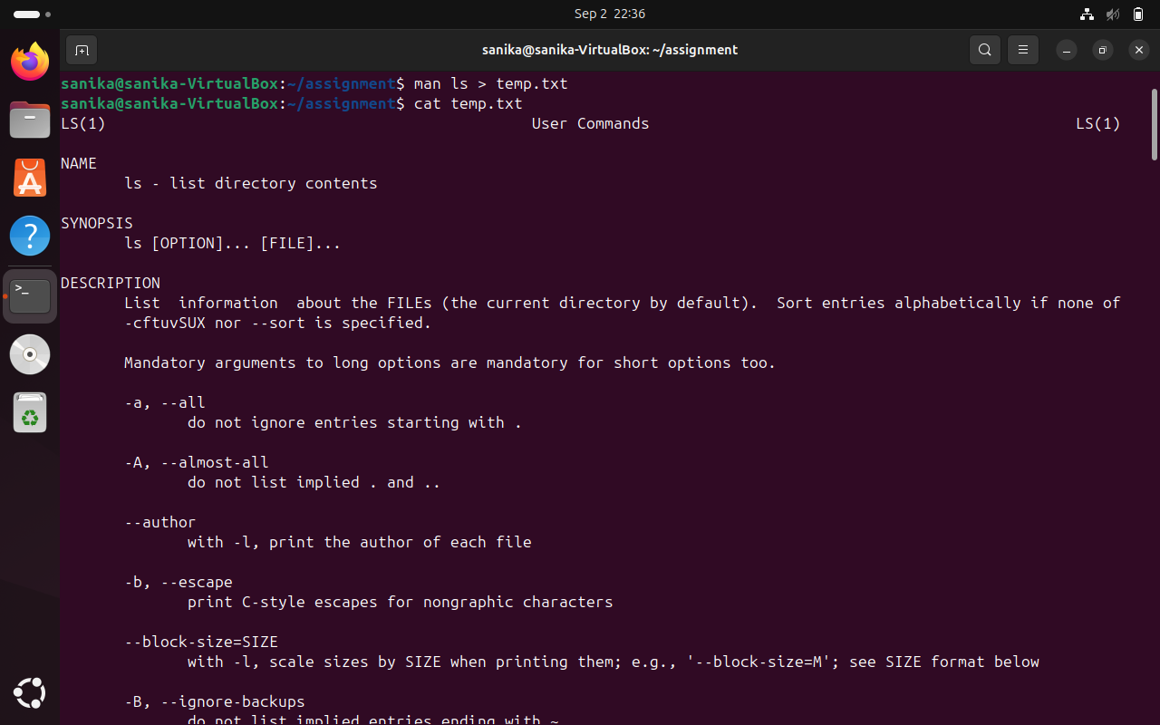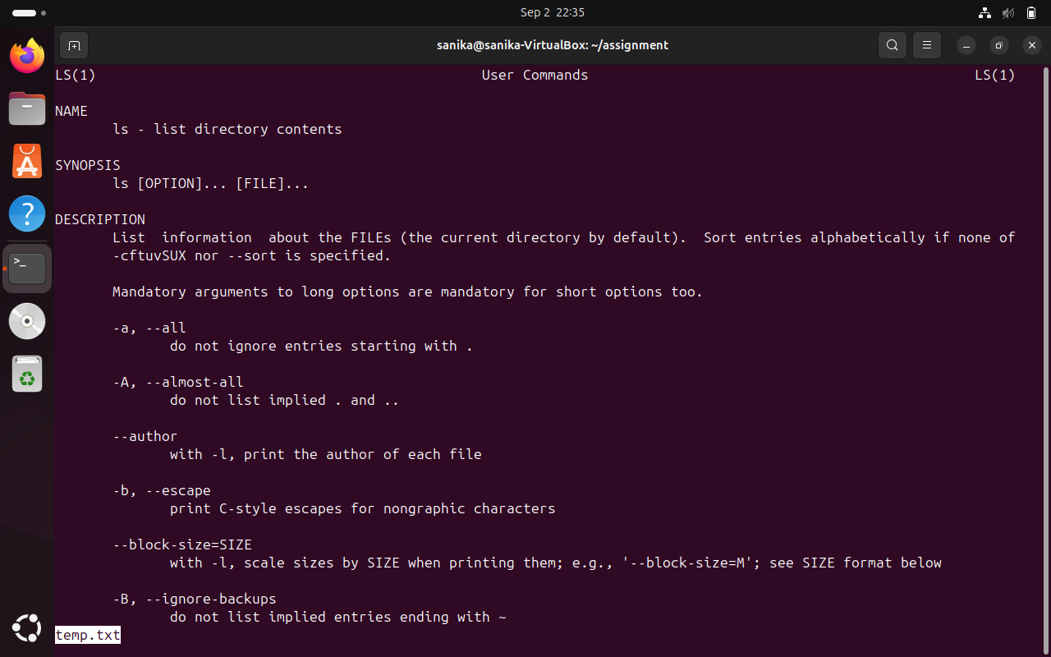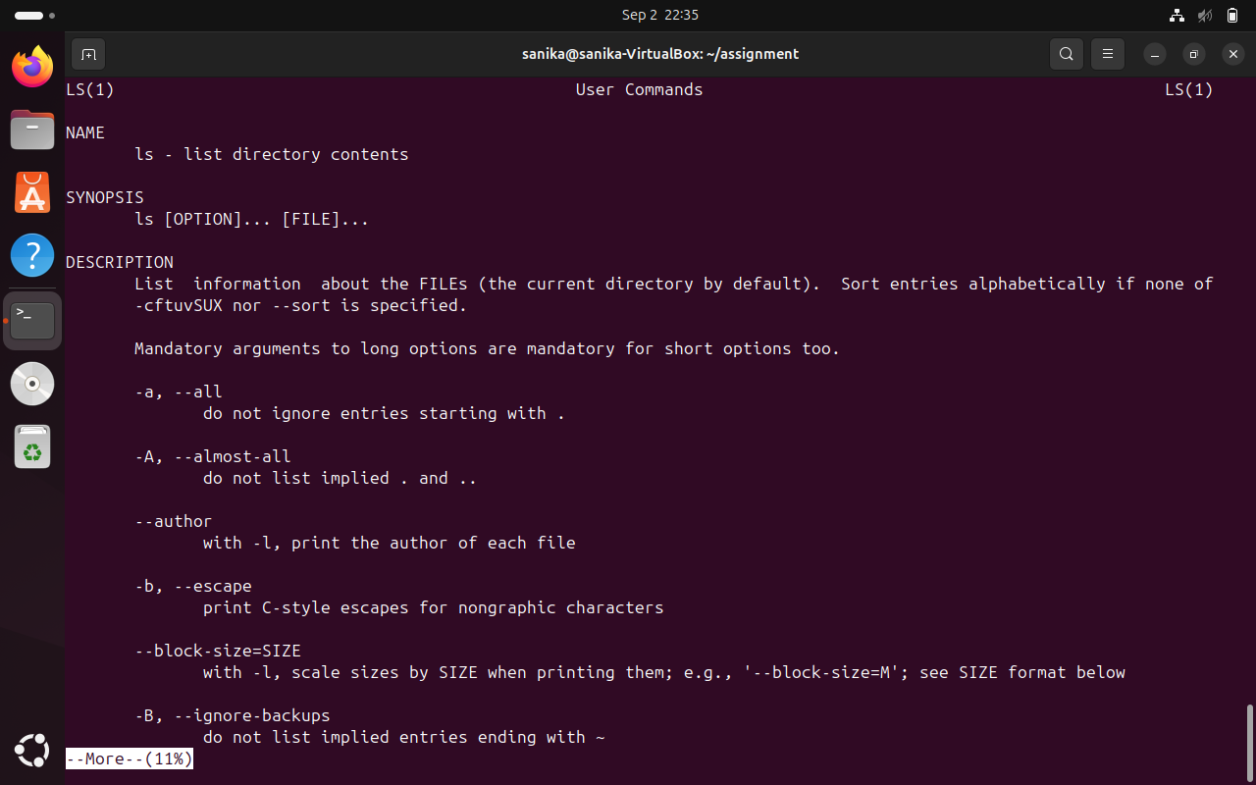

1. **Display the initial 10 lines and final 5 lines of temp.txt​ with the obvious Linux commands. (Hint: use head​ and tail​ commands).**

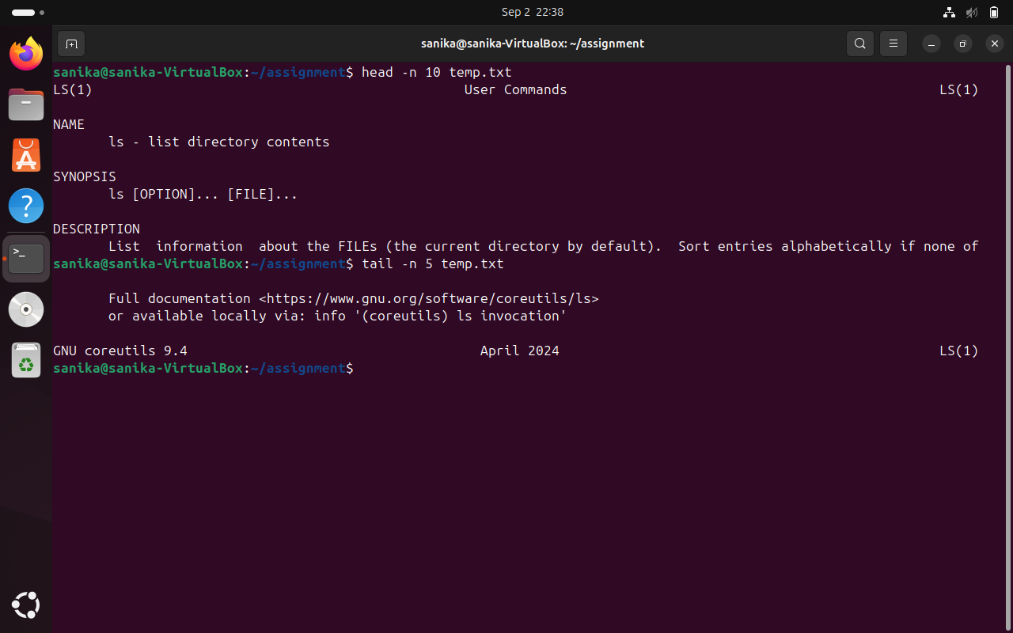

1. **Copy temp.txt​ to another directory and rename it there.**

**(Hint​: use cp​ to copy and mv​ command to rename).**

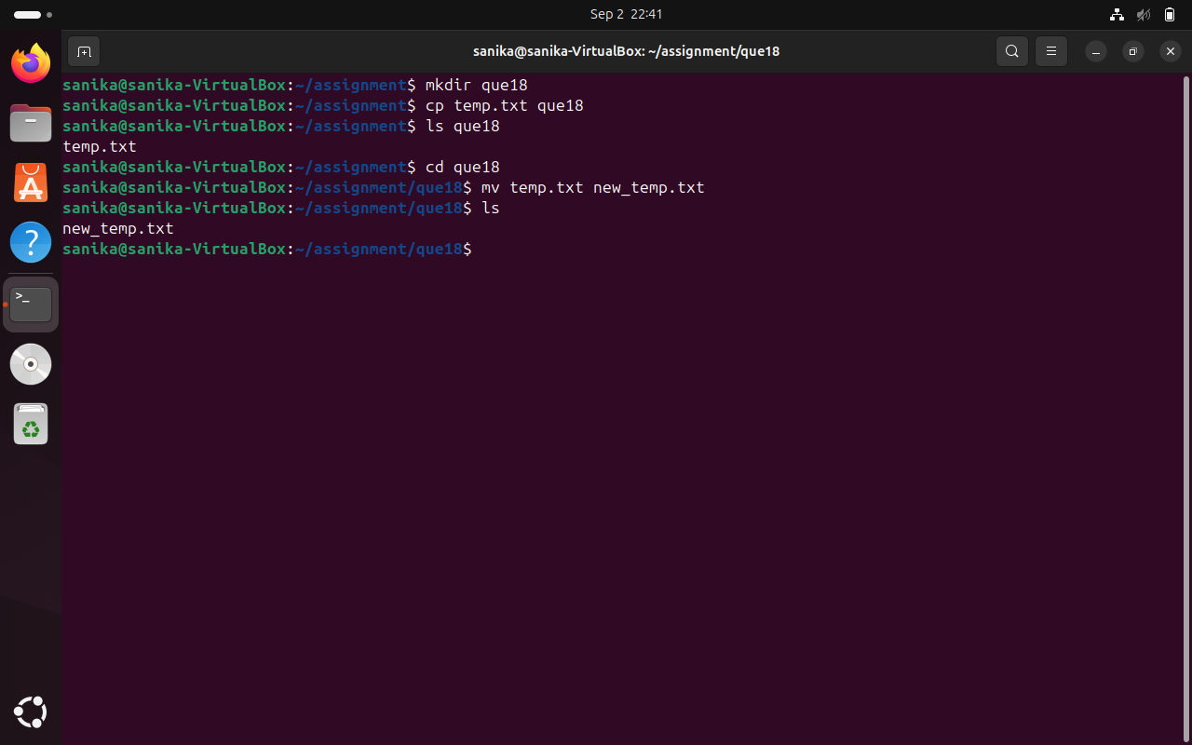

1. **Display the number of lines, words and characters in file using Linux command (Hint​: use wc ​command).**

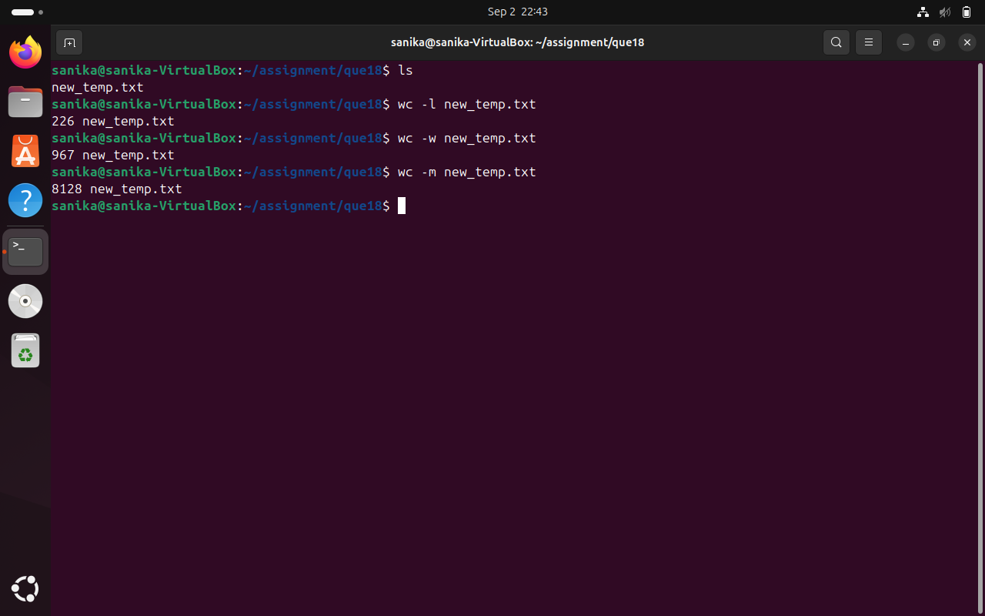

1. **Use history command to display the last 10 commands used. (Hint​: use history ​command).**

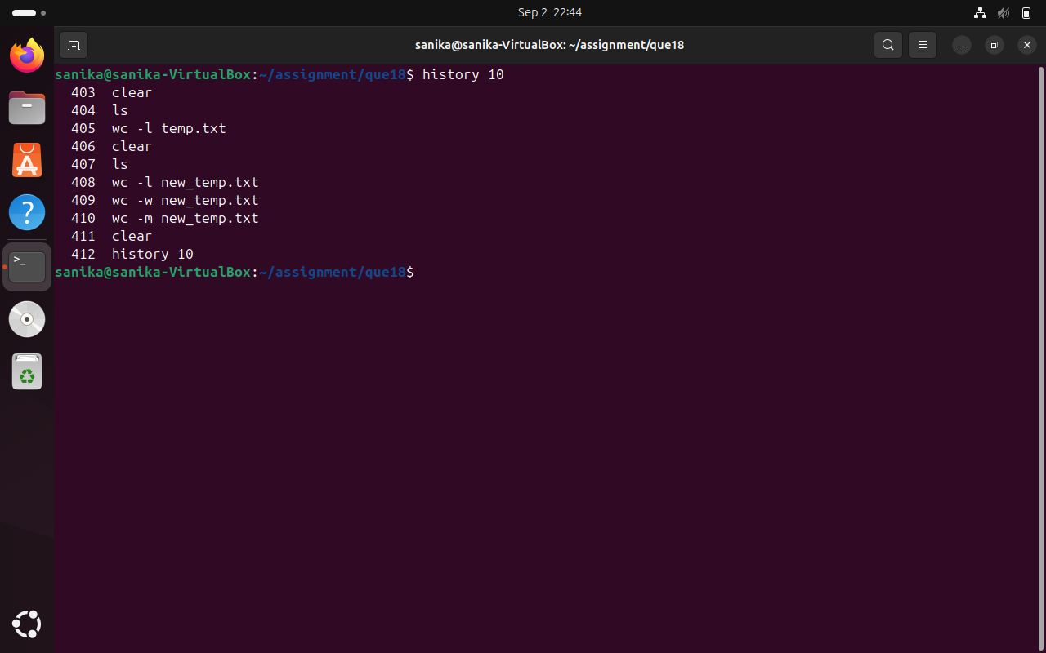

1. **Create a tar archive file of any directory present in your home directory. (Hint​: use tar ​command)**

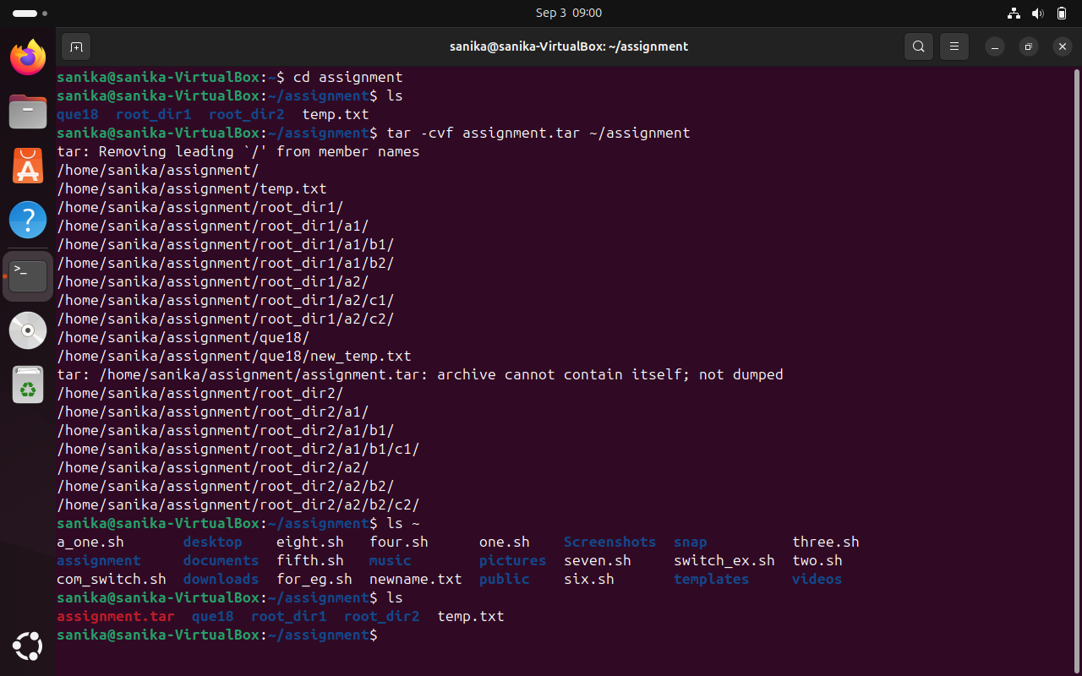

1. **Create a zip file of another directory. (Hint​: use zip ​command) - list the contents of the zip file without extracting.**

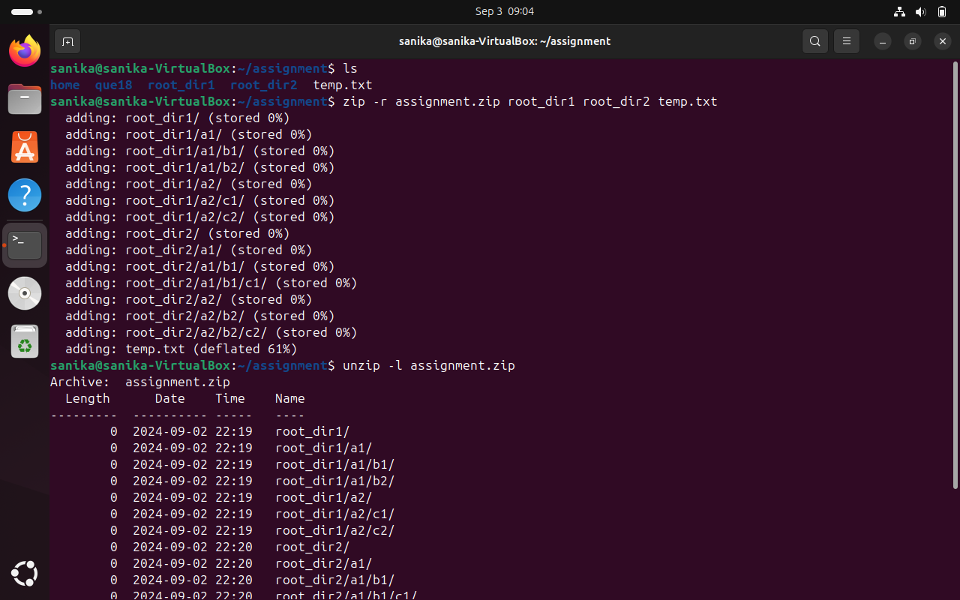

1. **Give read, write & execute permissions to your file. (Hint​: use chmod command)**

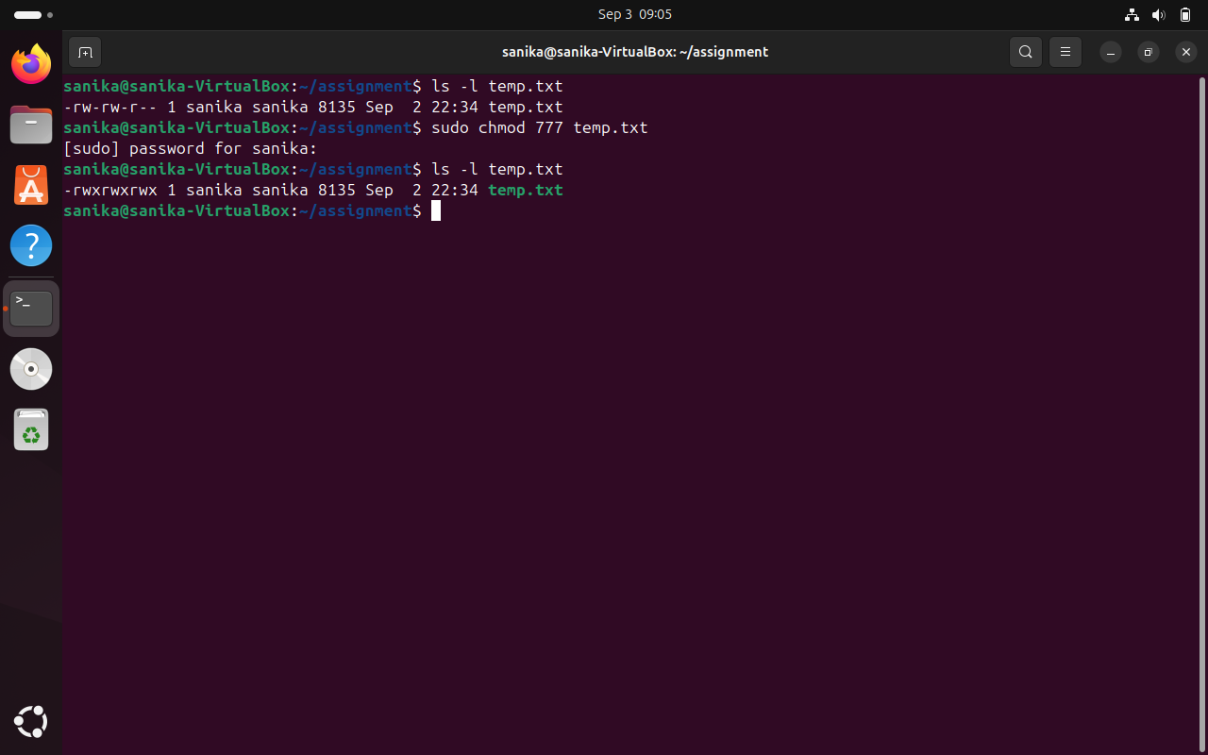

1. **Change ownership of that file. (Hint​: use chown​ command)**

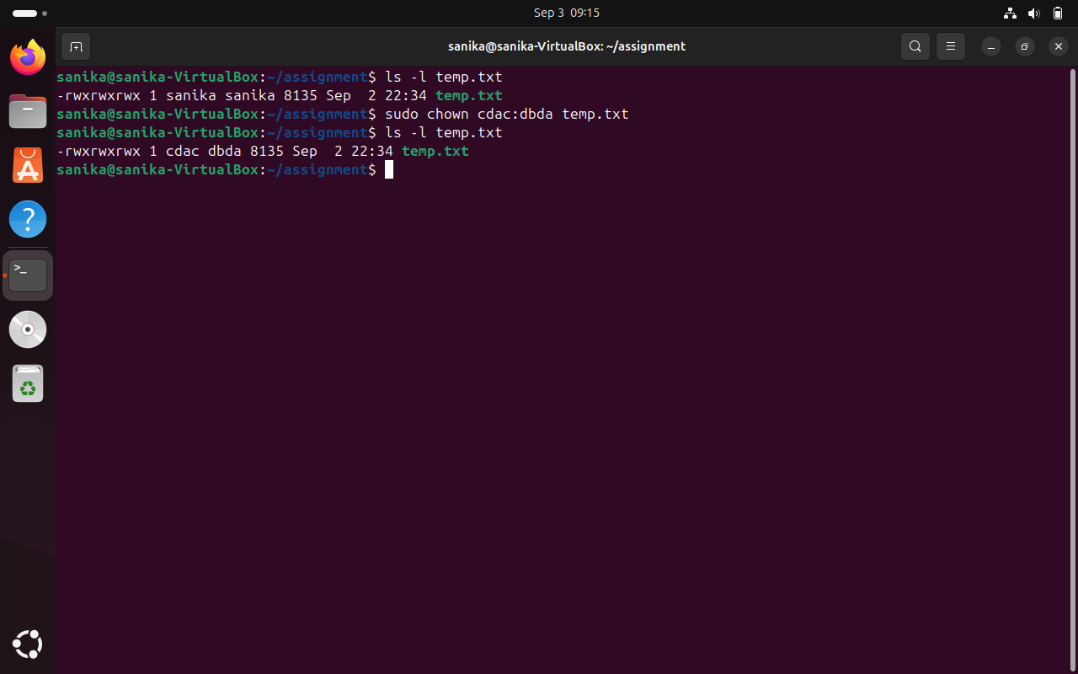

1. **List processes running in shell, all running processes (Hint​: use man page of ps ​command) and show top processes in decreasing order of their resource utilization. (Hint​: use top​ command).**

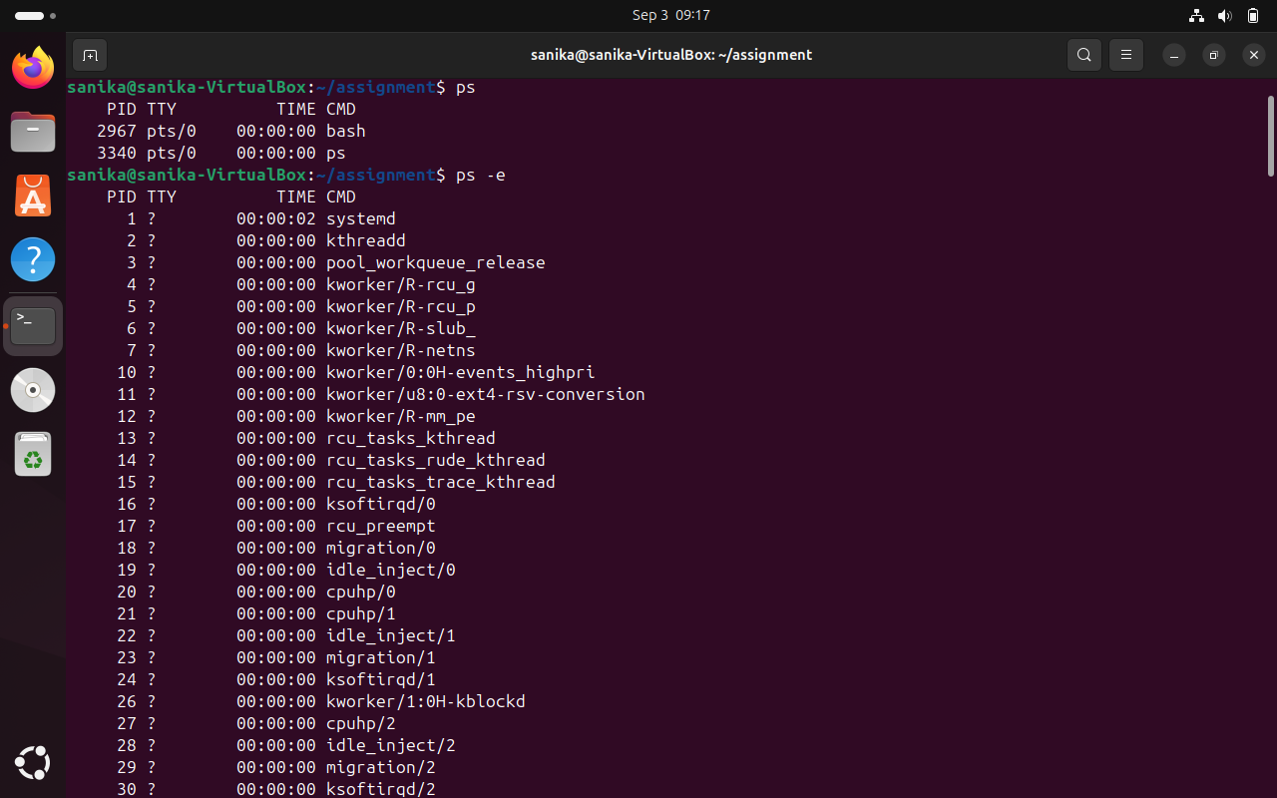 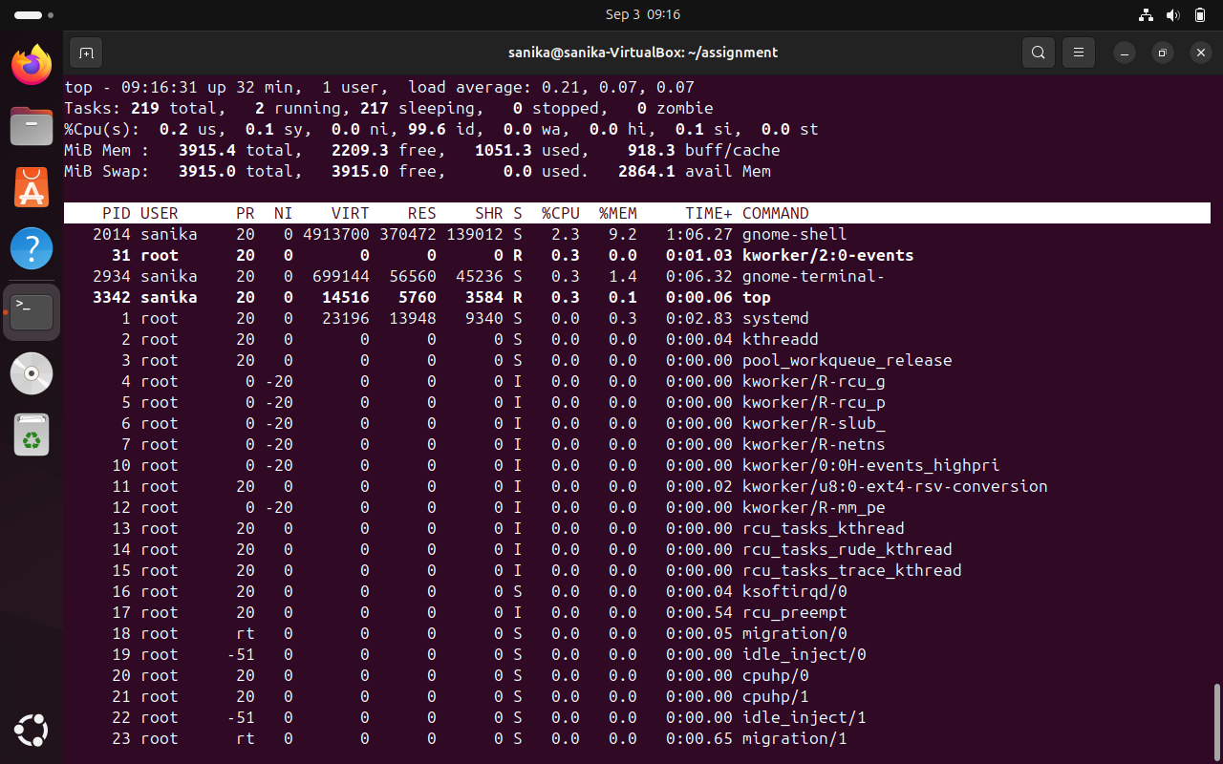

1. **A) Display current time and calendar (Hint​: use date, cal ​commands)**

**B) Change the current date and time of the system to following 14th March 2024, 10:10 AM**

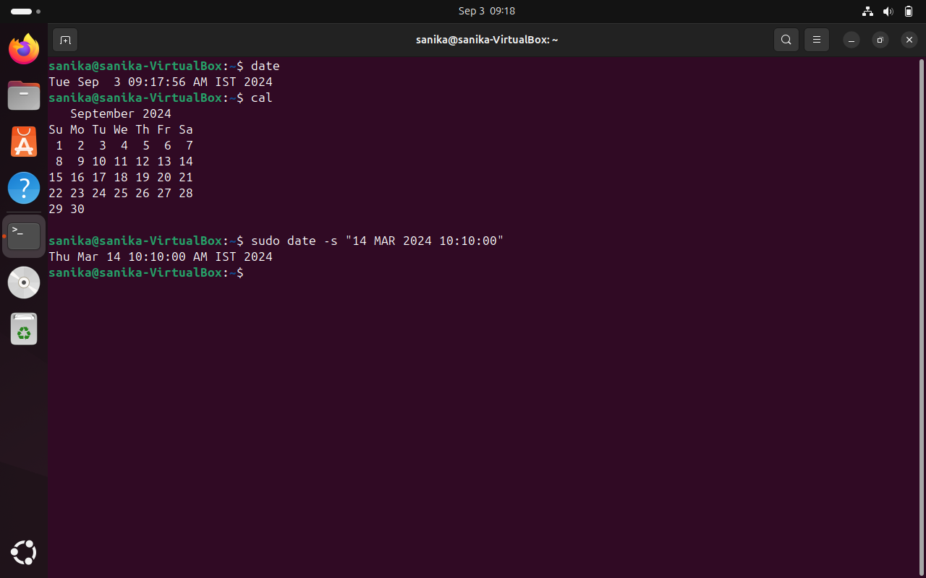

1. **Explore following commands**

**who, whoami, whatis, whereis, (Hint​: use man pages)**

1. **Create one directory named Linux. cd to that directory and create one file named testperms.txt. ​Check permissions of that file. Check value of umask​. Change the value of umask and create one new file newtestperms.txt ​and check its permissions. Note down the difference. (Hint: use umask, ls command)**

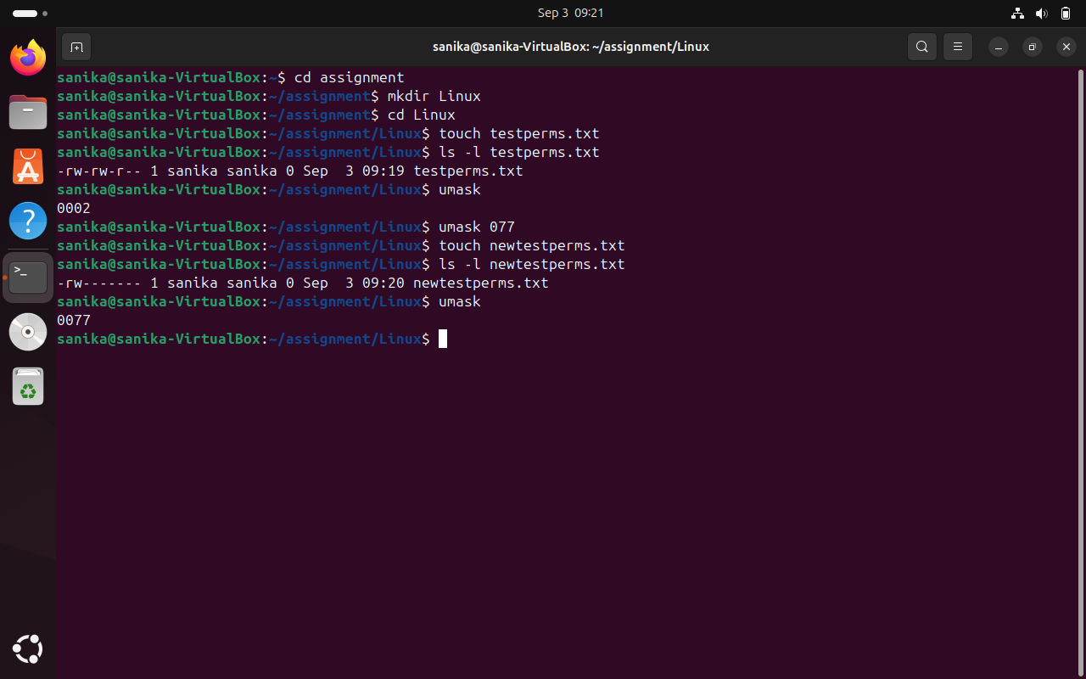

1. **Create a file and name it as file1.txt and create a hard link to this file. (Hint use ln​ command).**

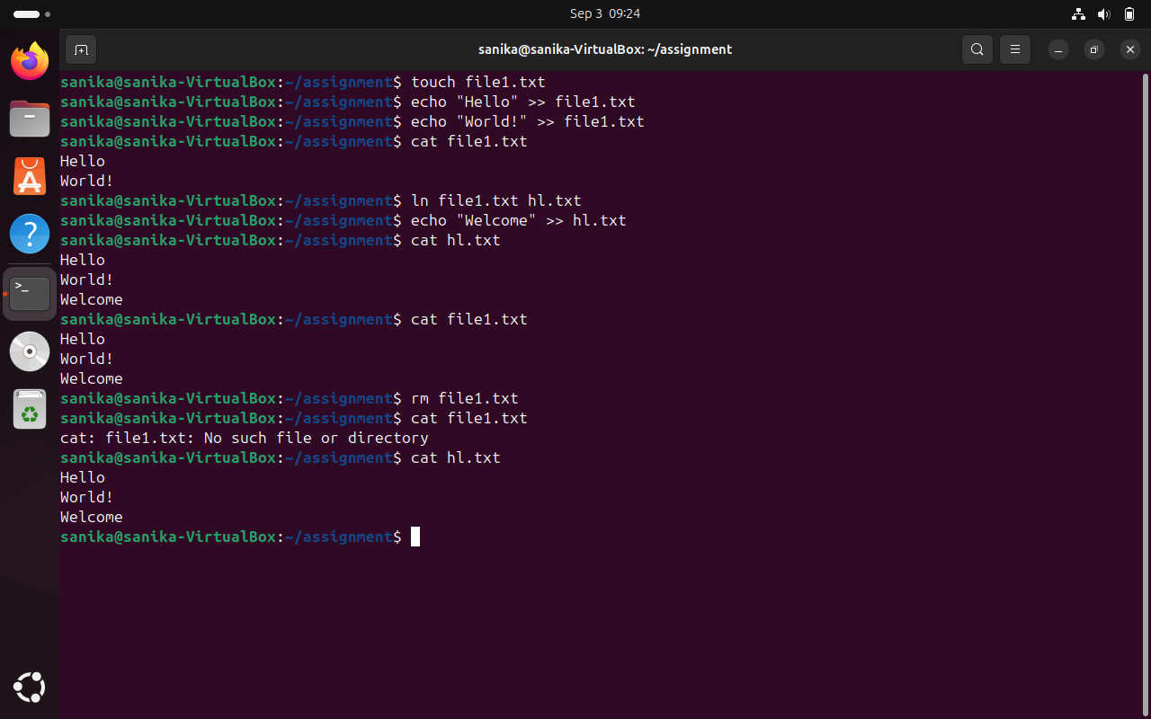

1. **Create a file and name it as file2.txt and create a soft link to this file. (Hint use ln​ command).**

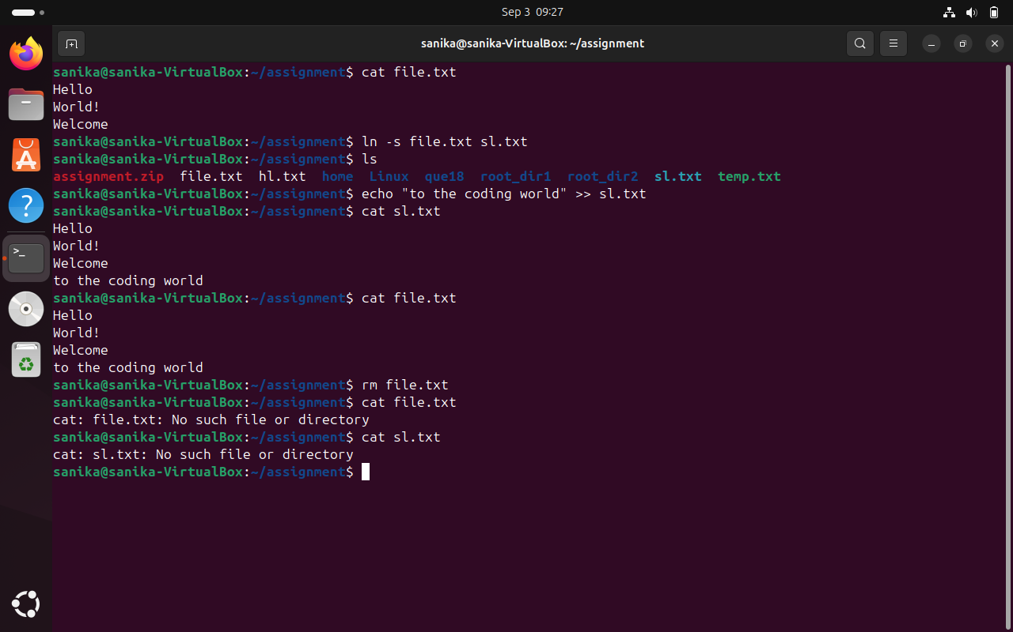

|  |  |
| --- | --- |
| **Hard Link** | **Soft link** |
| **Hard lng with being a link.** | **Soft link is a link which indicates path to**  **its parent files.** |
| **Since it is a file by itself, if parent file is**  **deleted, child file remains as it was**  **previously.** | **Since its a path, if parent file is deleted,**  **child doesn't point to proper path and**  **becomes a zombie file.** |
| **Can be used for creating backup files.** | **Can be used as a shortcut.** |
| **Syntax is: In parentfile.ext childfile.ext** | **Syntax is: In -s parentfile.ext Q**  **childfile.ext (here, -s indicates soft link)** |

1. **Use ssh​ to connect to your friend’s shell by specifying port number​ in the ssh command. use exit ​command to come out of your friend’s shell.**

**(Hint: use ssh​ command)**

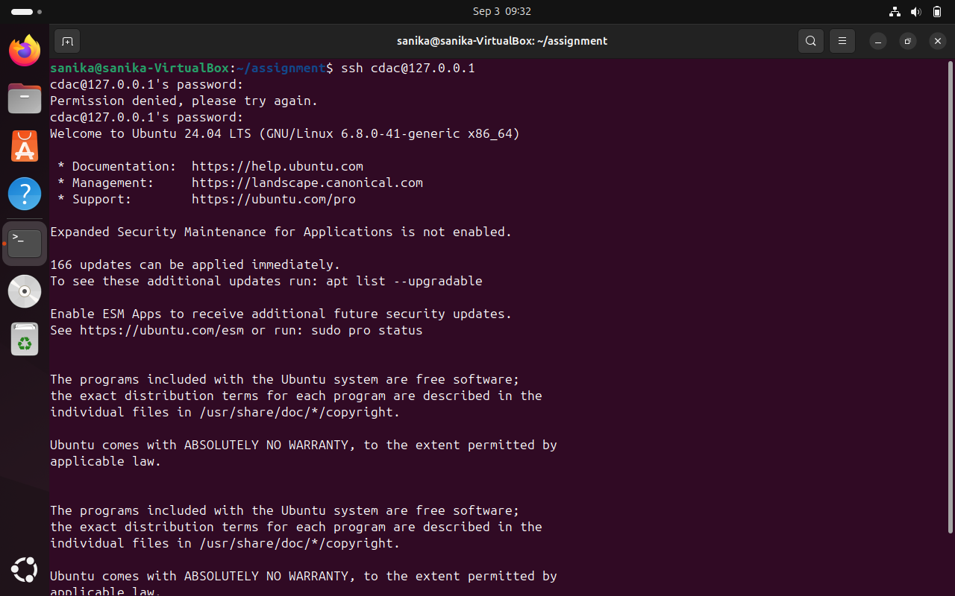

1. **Use scp​ using your friend's credentials to copy file​ into a directory owned by your friend, ​inside his home directory, specify port number in scp​ command.**
2. **Use scp​ using your friend's credentials to copy directory​ into a directory owned by you​, inside your home directory, specify port number in scp command**
3. **Use scp​ using your friend's credentials to copy directory​ into a directory owned by you​, inside your home directory, specify port number in scp command**
4. **Connect to any publicly available ftp​ server from terminal and try to download, upload and delete files. If you get error in any process (connect, upload, download or delete), justify the reasons behind them. (Hint: use ftp​ command) Example:**

**Try to access ftp.netbsd.org**

**username: anonymous**

**password: anonymous**

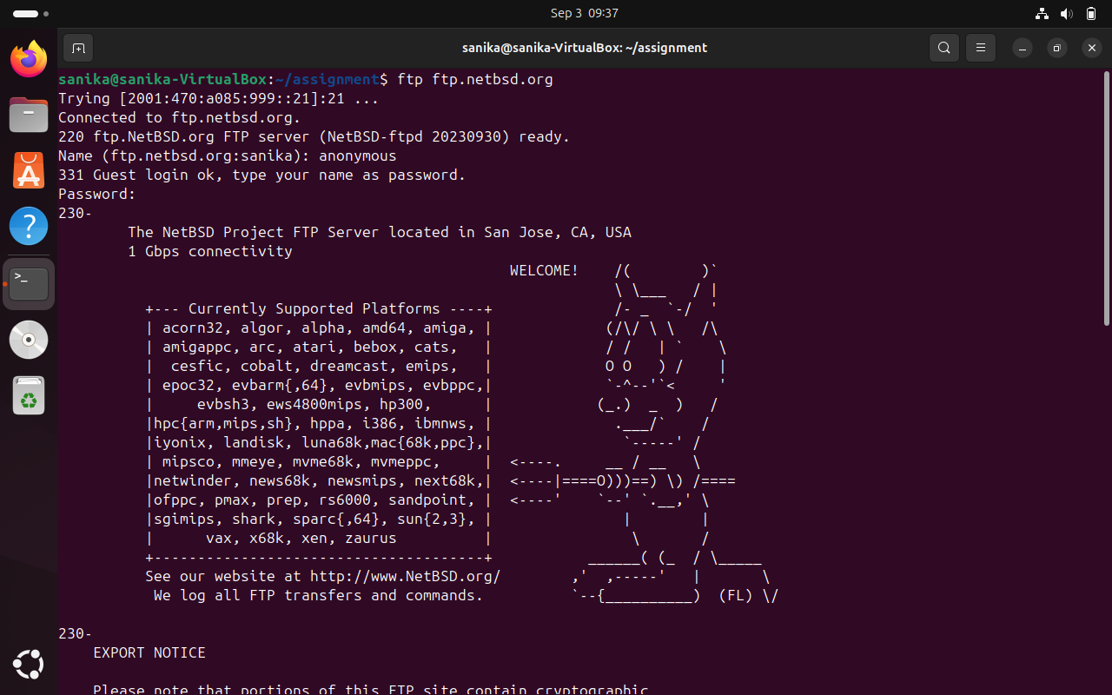

1. **How do you remove a directory named "mydir" and all of its contents using the command line?**

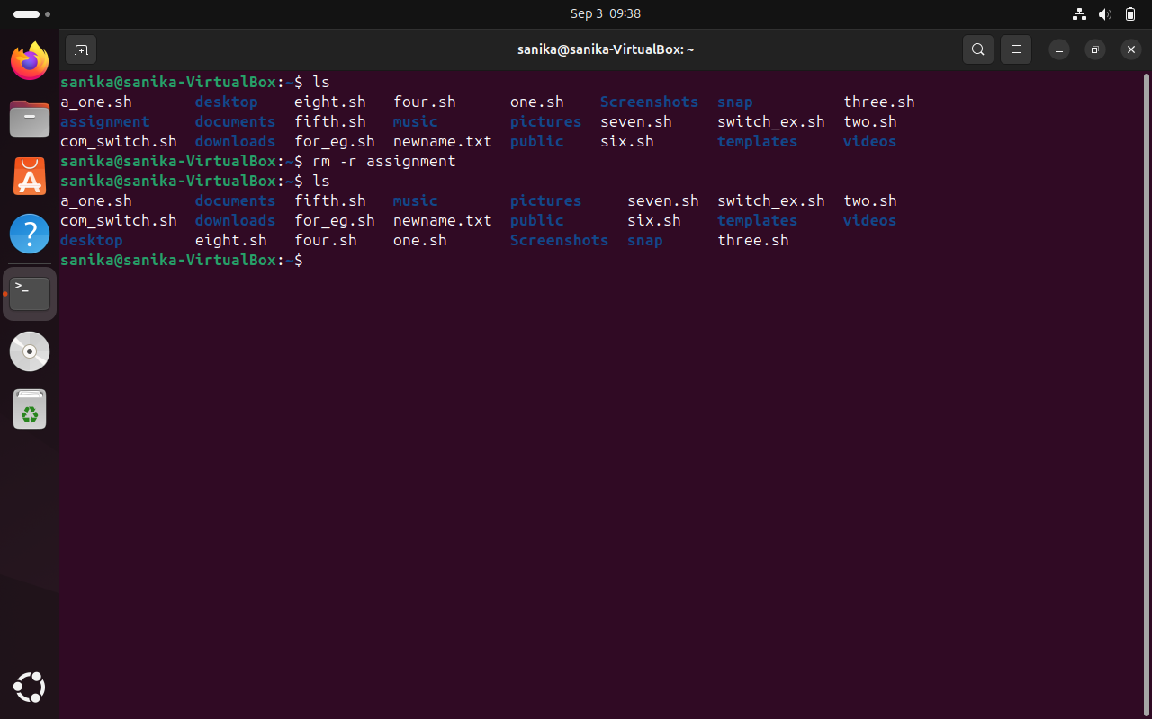

1. **How do you use the "ls" command to list all files and directories in the current directory?**

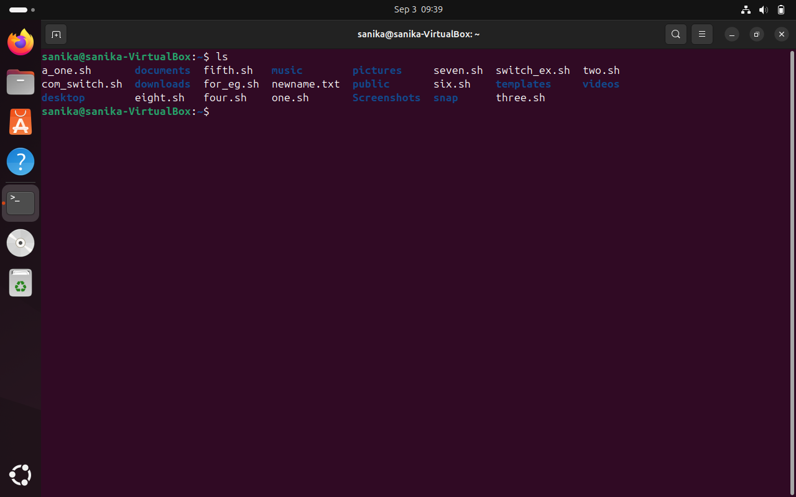

1. **How do you create a new file named "myfile.txt" in the directory "/home/user/documents" using the command line?**

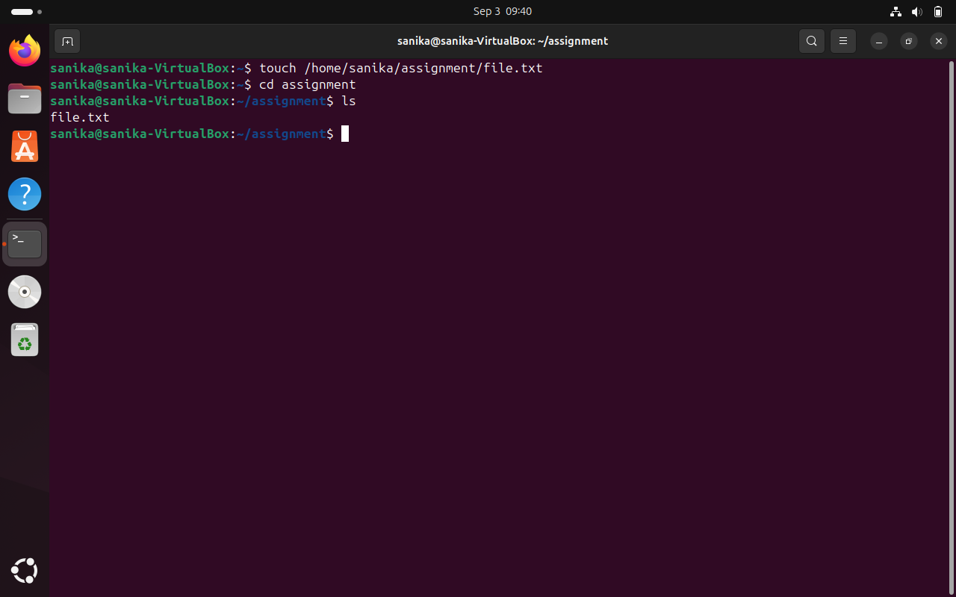

1. **How do you use the "grep" command to search for a specific word or phrase in multiple files at once?**

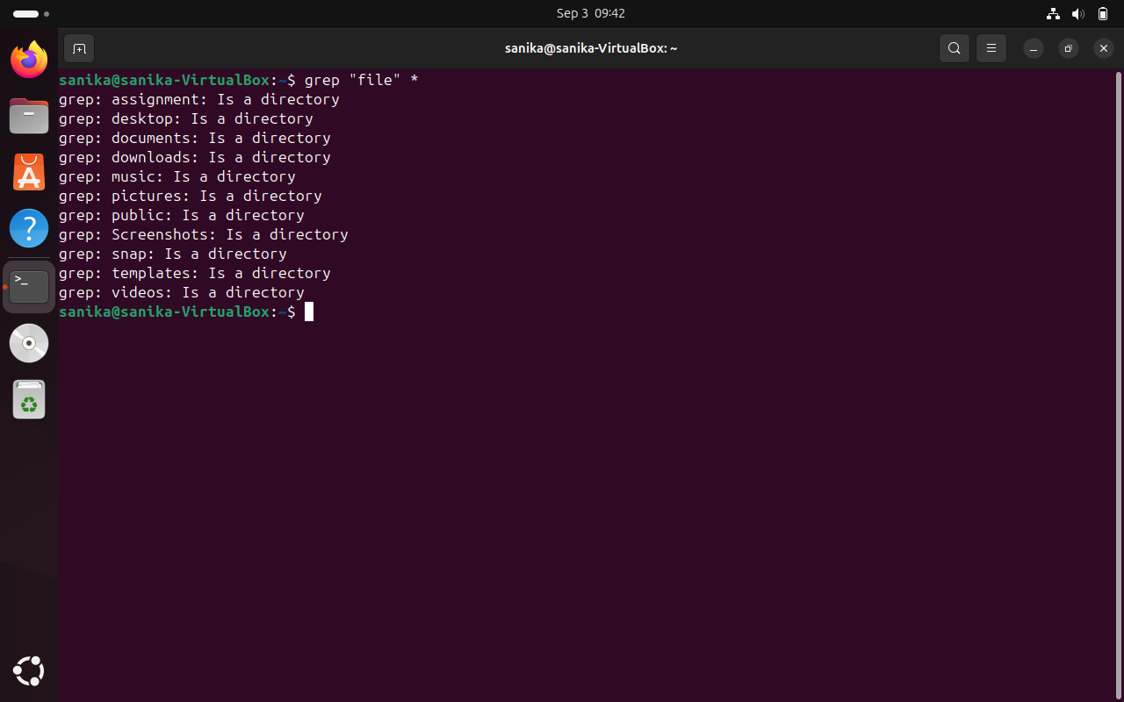

1. **How do you create a new directory named "mydir" and set its permissions to read, write, and execute for the owner and read and execute for everyone else?**

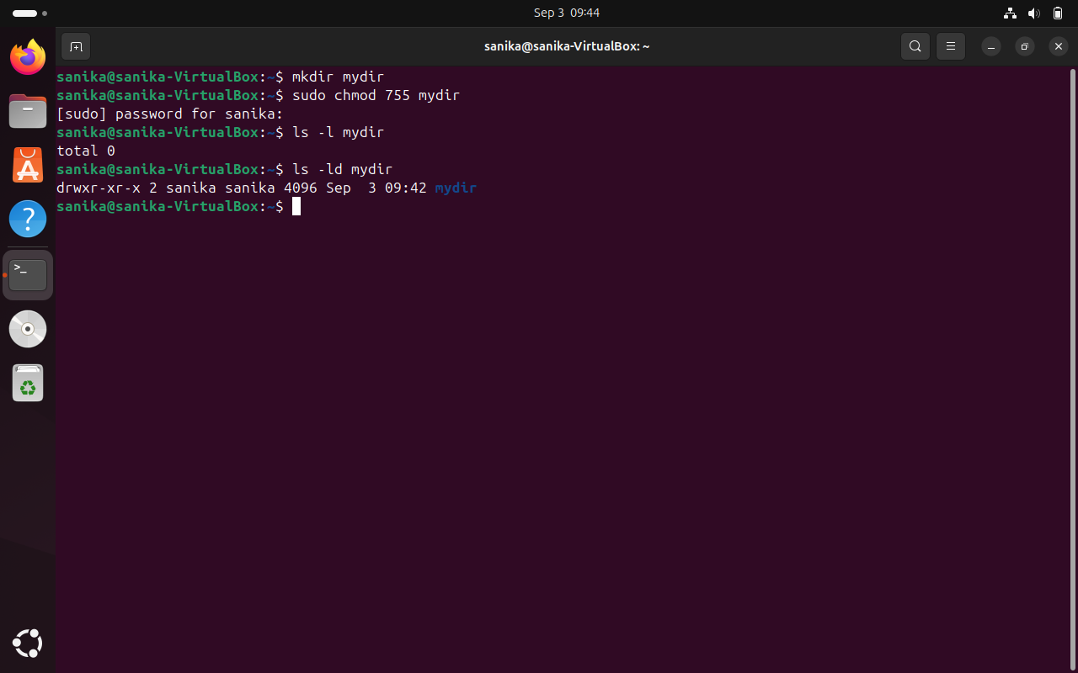

1. **How do you use the "tar" command to create a compressed archive of all files in the current directory and its subdirectories?**

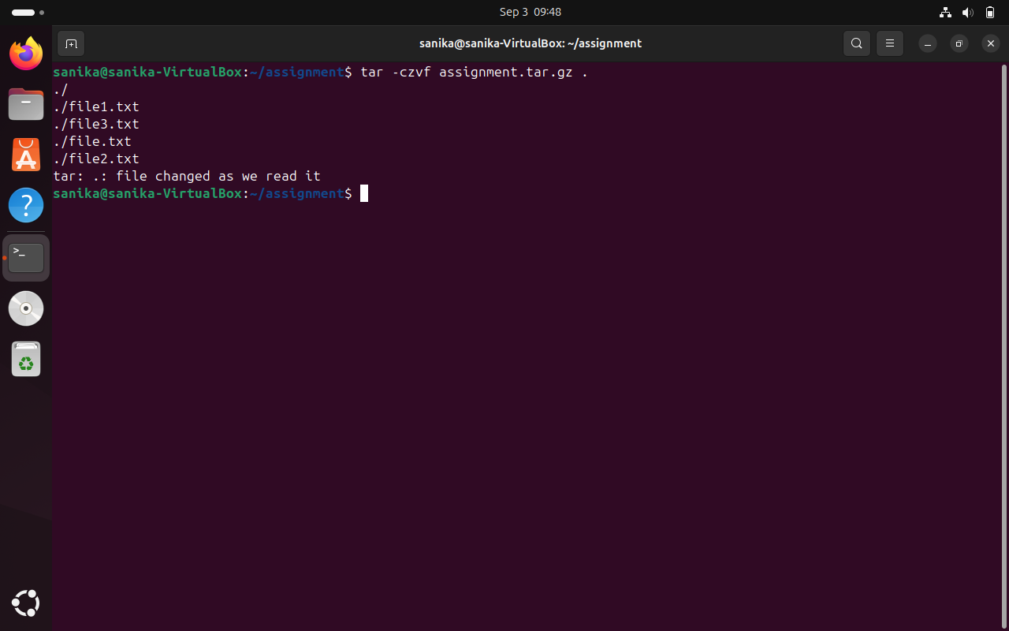

1. **How do you use the "chmod" command to give read and write permissions to the owner and group for a file named "file.txt"?**

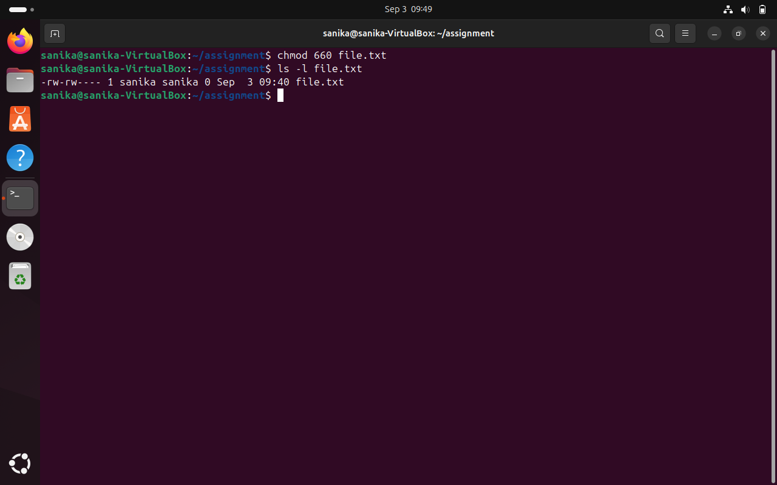

1. **How do you find the size of a file named "file.txt" in bytes, kilobytes, and megabytes using the command line?**

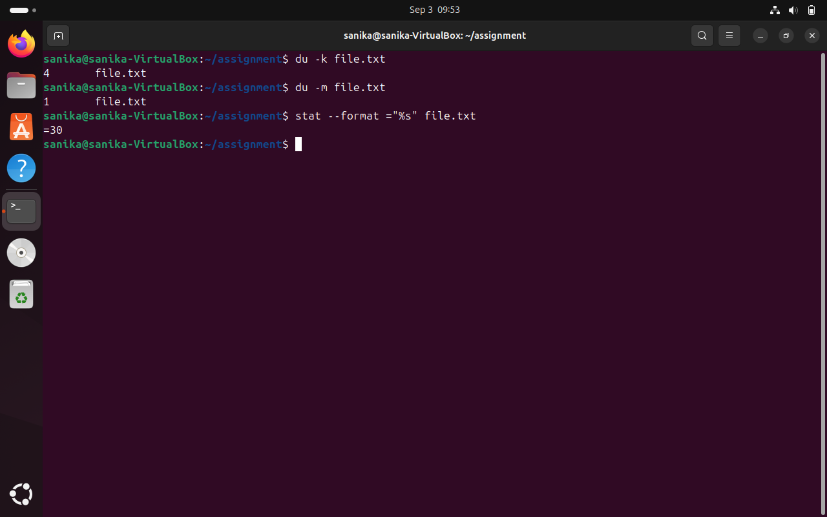

1. **How do you use the "awk" command to extract a specific column from a comma-separated value (CSV) file and sort it in reverse order?**
2. **How do you use the "sed" command to replace all occurrences of a word or phrase in a file with a different word or phrase?**

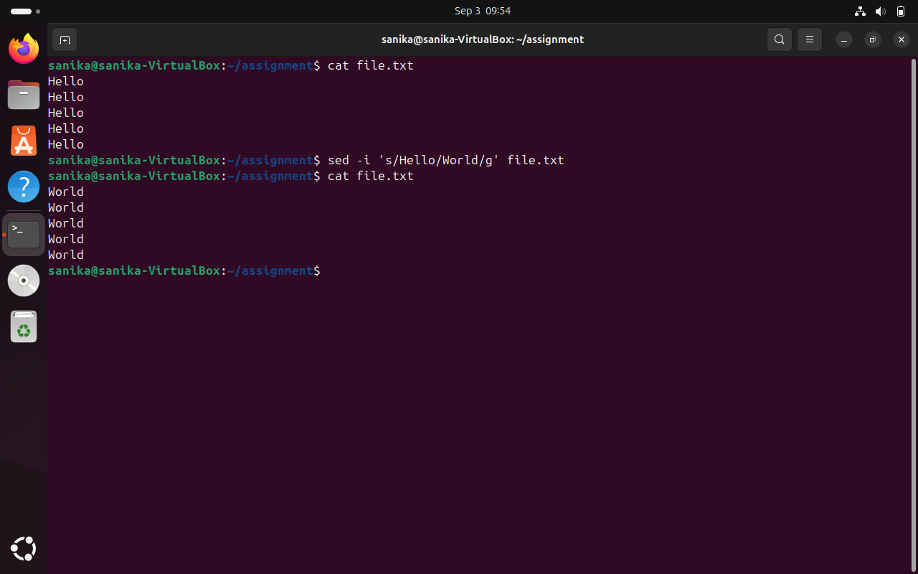

1. **How do you use the "find" command to search for all files in a directory and its subdirectories that were modified within the last 24 hours?**

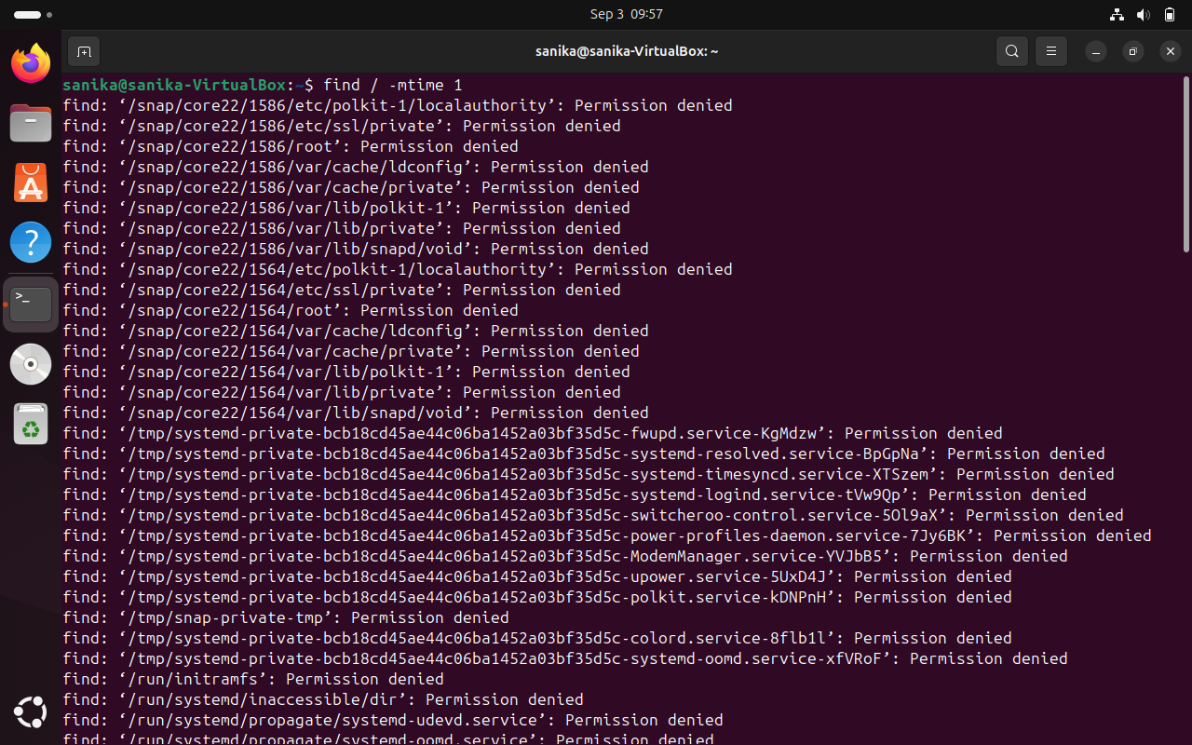

1. **How do you use the "diff" command to compare two files and show only the lines that are different between them?**

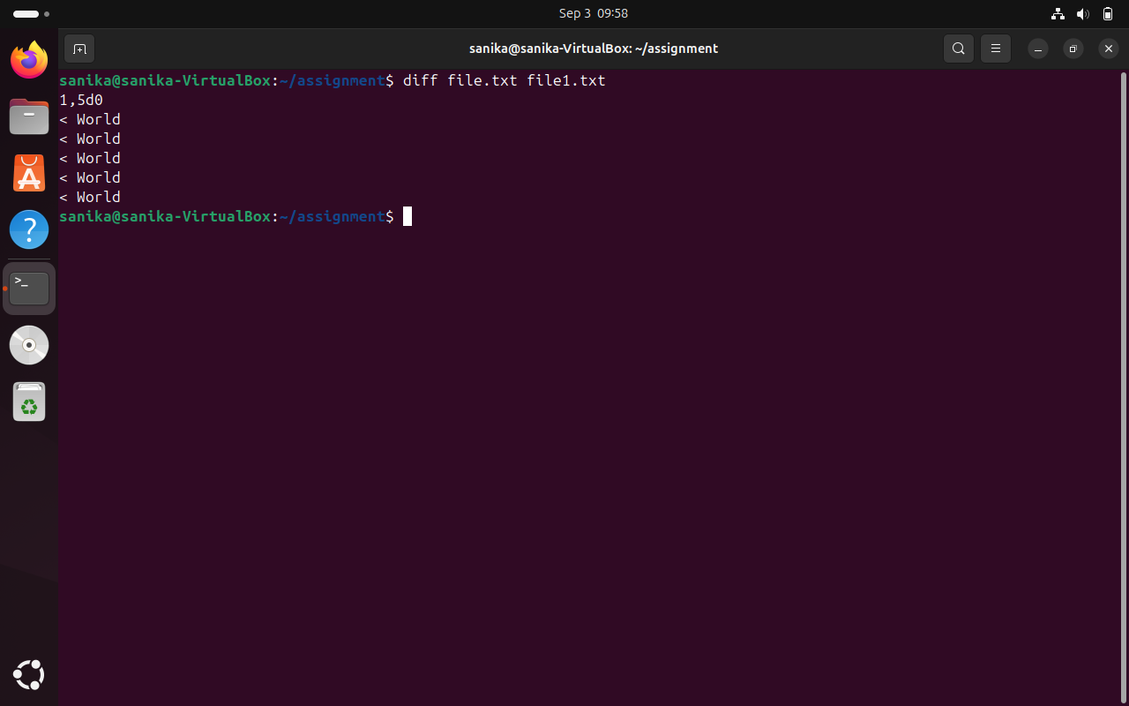

1. **How do you use the "rsync" command to synchronize the contents of two directories, including all subdirectories and files, while preserving file permissions and ownerships?**

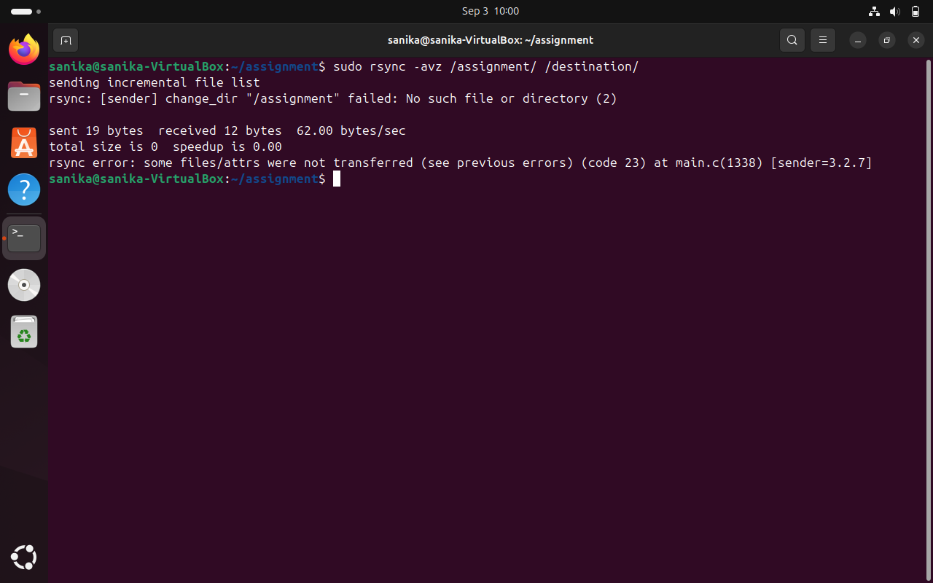

1. **How do you use the "cut" command to extract a specific range of characters or bytes from a file?**
2. **How do you use the "tar" command to extract a specific file or directory from a compressed archive without extracting the entire archive?**



1. **How do you use the "awk" command to count the number of occurrences of a specific word or phrase in a file?**